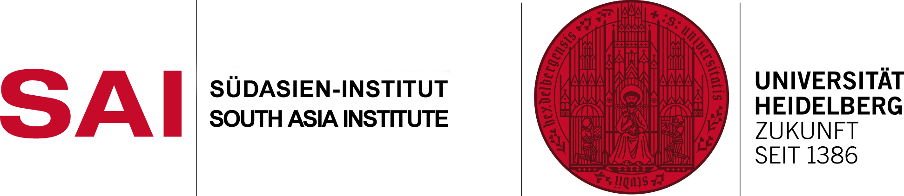
Application Form Modern South Asian (Summer School Pashto for Beginners) Languages and Literatures Last date of application: 30th June 2015 Im Neuenheimer Feld 330
69120 Heidelberg, Germany
Tel.: +49 (0)6221 548837
Fax: +49 (0)6221 548841
E-Mail: Oesterheld@uni-heidelberg.de
samantha.kanna@gmx.net

Sirname, Name:
Date of Birth: | Sex :
Nationality:
Address:
Telefon: | E-Mail:
Occupation: | Degree / Subjects:

Years or Months of studies in  Urdu: | Persian:
Arabic: | Hindi:
Need an accommodation ?

